OFFICE USE ONLY
Sift | Unsuccessful / Invite to Interview / Suggest Alt Role __________________ (Agreed ______)
Int | Date _______ Time ________ |  | Interviewer __________ | Role(s) __________________
Result | Unsuccessful | Appt _________________________ Start _________ End _________
 | Reserve _________ | To be Appt ____________________ Start _________ End _________
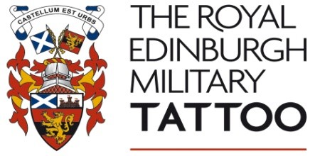
Application for Temporary Employment (EVENT-Based)
Applicants should read Job Descriptions before completing this form – available at www.edintattoo.co.uk. Please email your completed form as an attachment to employment@edintattoo.co.uk or return to ‘Recruitment, The Royal Edinburgh Military Tattoo, 3 Cockburn Street, Edinburgh, EH1 1QB’ before Monday 8 April 2019.

Preferences  (tick all that apply) | Event Steward Media Liaison Officer  Usher General Assistant Wherever the role takes me
Any dates you are unavailable?
Have you worked with us before?
Where did you hear about this job?

Personal Details
Surname |  | First Name (s)
Address Line 1 |  | Email address
Address Line 2 |  | Home Tel No
Town/City |  | Daytime Tel No
Postcode |  | Mobile Tel No

Previous Experience Please summarise experience in paid/voluntary roles in the last 3 years. (Box can be expanded)
Employer's Name | Your Job Title | Main Duties | Dates | Reason for Leaving

Education and Training Please note last 3 years’ and other relevant qualifications/training. (Box can be expanded)
Name of Education Provider | Dates of Study | Subject Studied | Grade/Band | Achieved

Additional Information Please set out why you would like to work for The Royal Edinburgh Military Tattoo and any further information to support your application. (Box can be expanded)

 | Applicants with Disabilities
 | Disability Discrimination Act 1995 defines a disabled person as anyone who has a physical or mental impairment which has a substantial and long term effect on their ability to carry out normal day to day activities. You do not have to be registered disabled. Applications from suitably qualified disabled people are positively welcomed.
 | Taking this definition into consideration do you consider yourself to have a disability? |  | Yes |  | No
 | If you are shortlisted for interview, do you have any specific requirements? (e.g. British Sign Language interpreter, wheelchair access, induction loop system, etc.) |  | Yes |  | No
 | If Yes, please specify:
Additional Personal Information
If offered employment you will be required to complete a Medical Questionnaire and Right to Work checks for employment records, do you accept this as part of the terms of your employment? (tick/cross to agree)
Please add me to your mailing list to receive information about other recruitment at The Royal Edinburgh Military Tattoo in the future, which I may later opt out of (tick/cross to agree)
- The information I have given on this form is true and accurate to the best of my knowledge. I understand that providing false information is an offence and could result in my application being rejected or summary dismissal.
- I have read or had explained to me and understand all the questions on the form.
- I understand that in accordance with data protection legislation, the personal details submitted with this application form will be used only for selection and interview procedures and for employment records if successful.
- If I am not appointed, I understand that these details will be kept on file for two years.
Signed:  If you submit your application by email you may be asked to sign the declaration later. |  | Date:

